**Formulae for Solid Oxide Fuel Cells**

***Output Voltage***

*Output Voltage = Nernst Voltage – (Activation Loss + Concentration loss + Ohmic Loss )*

*Vfc = Enernst – (Vact + Vcon + Vohmic)*

***Nernst Equation***

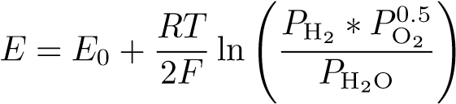

*Where*

*E0 = 1.1 V is the standard potential*

*R = 8.314 kJ/ kmol .K is the universal gas constant*

*T = operating temperature of the fuel cell in kelvins*

*F = 96486 C/mol is the Faraday constant*

***Output current Density***

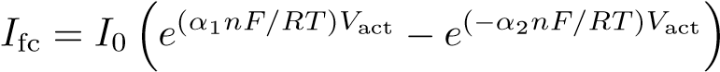

*where -*

*I0 is the exchange current*

*αi is the coefficient of charge transfer*

*n = 2 is the number of moles of electrons transferred*

***Exchange Current Density***

*I0 = A(e−Eact)/RT*

*where –*

*A = 101.2 kA/cm2 is a preexponential factor obtained by curve fitting with the distributed model*

*Eact = 120 kJ/mol is the activation energy of the electrochemical reaction*

***Partial Pressures***

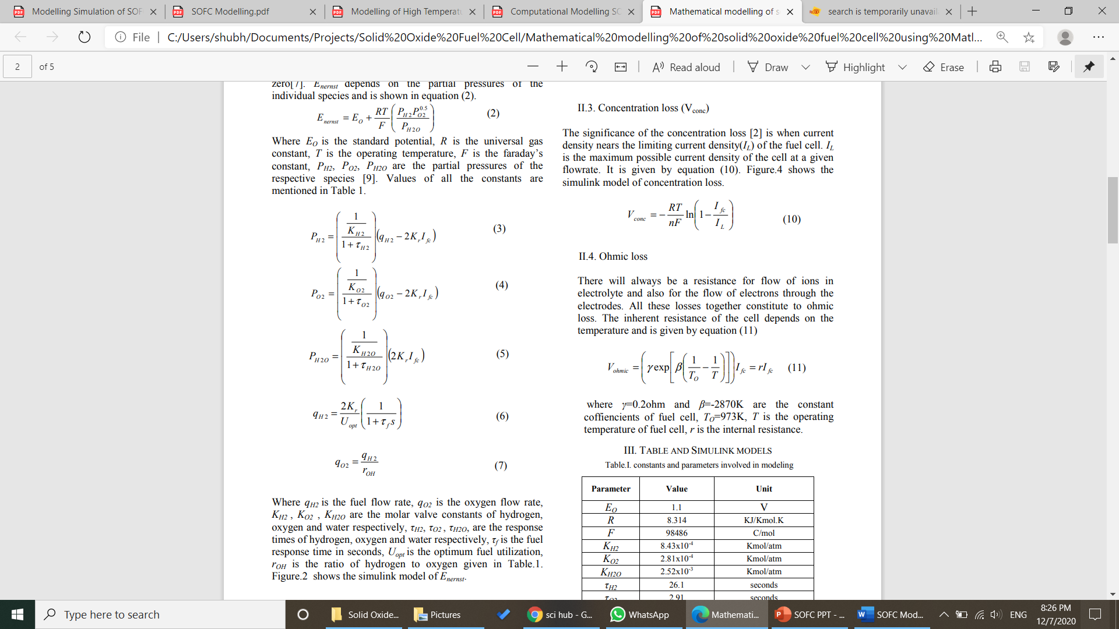

Where

* *qH2* is the fuel flow rate
* *qO2* is the oxygen flow rate
* *KH2 , KO2 , KH2O* are the molar valve constants of hydrogen, oxygen and water respectively,
* *τH2, τO2 , τH2O,* are the response times of hydrogen, oxygen and water respectively,
* *τf* is the fuel response time in seconds,
* *Uopt* is the optimum fuel utilization,
* *rOH* is the ratio of hydrogen to oxygen
* *Kr* = 1/(8F).

***Activation Loss***

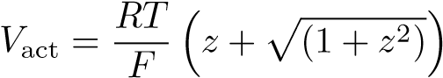

*Where*

*I0 is the exchange current*

*αi is the coefficient of charge transfer*

*n = 2 is the number of moles of electrons transferred.*

***Concentration Loss***

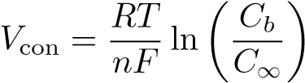

***OR***

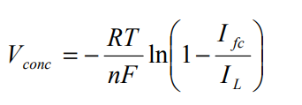

*Where*

*Cb is the concentration at the triple-phase boundary (tbp) where the gas, electrolyte,*

*C∞ is the bulk concentration of reactant*

*n is the number of moles of electrons participating in the reaction*

*I*L is the maximum possible current density of the cell at a given flowrate

*I*fc is the given current density

***Ohmic Loss***

*Vohmic* 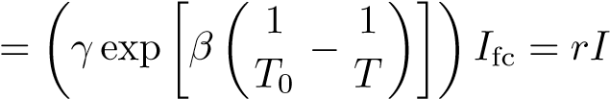

*where*

*T is the fuel cell temperature*

*T0 = 973 K*

*γ = 0.2 Ω, and β = −2870 K are the constant coefficients of the fuel cell*

*r is the internal resistance of the SOFC*

***Constants and Parameters Used***

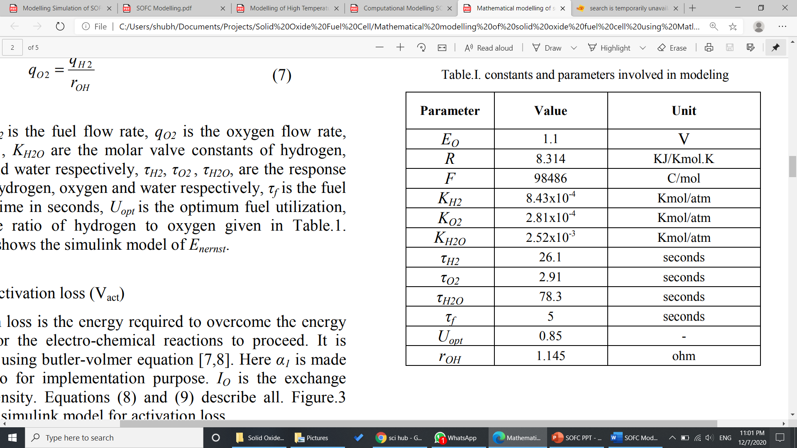

**References:**

1. Modeling and Simulation of Solid Oxide Fuel Cell Based Distributed Generation System 1Mukesh Kumar Baliwal, 2Dr.A.Bhargava, 3Mr. S.N. Joshi, 4 Sunil kumar - International Journal of Engineering Research & Technology (IJERT) Vol. 2 Issue 8, August - 2013 IJERT ISSN: 2278-0181
2. Solid Oxide Fuel Cell Modeling Abraham Gebregergis, Member, IEEE, Pragasen Pillay, Fellow, IEEE, Debangsu Bhattacharyya, and Raghunathan Rengaswemy
3. Mathematical modelling of solid oxide fuel cell using Matlab/Simulink TVVS Lakshmi, P Geethanjali and Krishna Prasad S - International Conference on Microelectronics, Communication and Renewable Energy (ICMiCR-2013)